zaza

Circus Artist

Work History

Education

Experience
Email

Acts
Areal Strap
Cyr wheel
Balance

TEZAZU AGEZA
- Gender: M
- Nat’l: ERI
- 731472

- Highly motivated and passionate about dance.
- Acting, dancing and performing as various characters in several shows.
- Managing staff, client relations, event planning and advertising.
- Creating and performing various Solo and Group acts.

- Diploma at National Circus School, A.A (Jan 2018-Feb 2022)
- Certificate for modern dance skill, A.A (Jan 2010-Dec 2010)
- Certificate for Traditional meets urban dance workshops, A.A (Aug 26-30, 2019)
- Certificate for Training in Contemporary dance, A.A (Aug 10-14, 2016)

- Freelancer Circus Artist at, Turkey, Qatar, Greece

- zazacircus@gmail.com

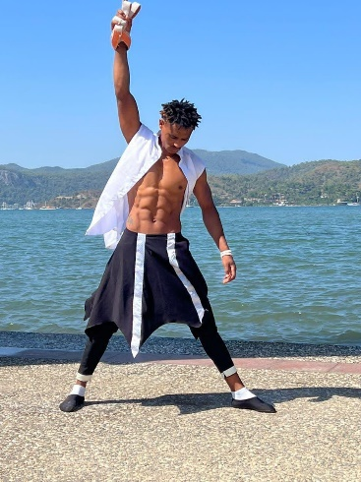 | 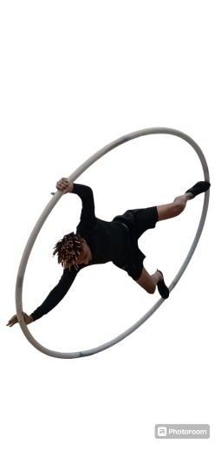 | 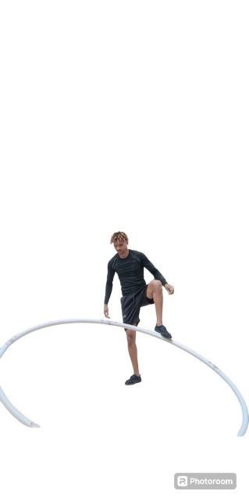 | 